JAVASCRIPT BASICS

1. ARRAYS

Requirements:

* Array’s should have a place to store.
* Array’s should have a way to display.
* Array’s should have a way to add new list.
* Array’s should have a way to change a list.
* Array’s should have a way to delete a list.
* Array’s should have a place to store.

In Browsers Inspect mode -> console type the following

["item 1","item 2", "item 3"] 🡪 It’s a list but it is called as Array in programming language

(3) ["item 1", "item 2", "item 3"]

var todos = ["item 1","item 2", "item 3"] 🡪 storing the array in a variable

undefined

todos 🡪 access the array by just calling the variable name

(3) ["item 1", "item 2", "item 3"]

* Array’s should have a way to display.

console.log(todos)

VM173:1 (3) ["item 1", "item 2", "item 3"]

undefined

console.log('My Todos:',todos)

VM209:1 My Todos: (3) ["item 1", "item 2", "item 3"]

* Array’s should have a way to add new list.

todos.push('item 4')

4

todos

(4) ["item 1", "item 2", "item 3", "item 4"]

todos.push('item 5')

5

todos

(5) ["item 1", "item 2", "item 3", "item 4", "item 5"]

* Array’s should have a way to change list.

todos[0] = 'item 1 updated'

"item 1 updated"

todos

(5) ["item 1 updated", "item 2", "item 3", "item 4", "item 5"]

* Array’s should have a way to delete list.

todos

(5) ["item 1 updated", "item 2", "item 3", "item 4", "item 5"]

todos.splice(0,1) //(0,1) ( '0' which item to delete, '1' how many items to delete)

["item 1 updated"]

todos

(4) ["item 2", "item 3", "item 4", "item 5"]

1. Functions

Structure of a function

function makeTurkeySandwich(){

GetOneSliceOfBread;

Add Turkey;

Put a slice of bread on top;

}

makeTurkeySandwich()

Customizing function

Function makeSandwichWith(filling){

GetOneSliceOfBread;

Add **fililng**;

Put a slice of bread on top;

}

makeSandwichWith(ham)

More on custom functions

function sayHiTo(person){

console.log("Hi", person);

}

undefined

sayHiTo('Ragav')

Hi Ragav

Function Requirements

* It should have a function to display todos
* It should have a function to add todos
* It should have a function to change todos
* It should have a function to delete todos
* It should have a function to display todos

todos

(4) ["item 2", "item 3", "item 4", "item 5"]

function displayTodos(){

console.log('My Todos:', todos);

}

displayTodos()

VM615:2 My Todos: (4) ["item 2", "item 3", "item 4", "item 5"]

* It should have a function to add todos

function addTodo(){

todos.push('new todo');

}

addTodo()

todos

(6) ["item 2", "item 3", "item 4", "item 5", "new todo", "new todo"]

displayTodos()

VM615:2 My Todos: (6) ["item 2", "item 3", "item 4", "item 5", "new todo", "new todo

Function addTodo(todo){

todos.push(todo);

displayTodos();

}

addTodo(‘new item’);

displayTodos()

* It should have a function to change todos

function changeTodo(position, newValue){

todos[position] = newValue;

displayTodos();

}

undefined

changeTodo(0,'changed')

VM615:2 My Todos: (6) ["changed", "item 3", "item 4", "item 5", "new todo", "new todo"]

undefined

* It should have a function to delete todos

function deleteTodo(position){

todos.splice(position,1);

displayTodos()

}

displayTodos()

VM615:2 My Todos: (6) ["changed", "item 3", "item 4", "item 5", "new todo", "new todo"]

undefined

deleteTodo(0)

VM615:2 My Todos: (5) ["item 3", "item 4", "item 5", "new todo", "new todo"]

Undefined

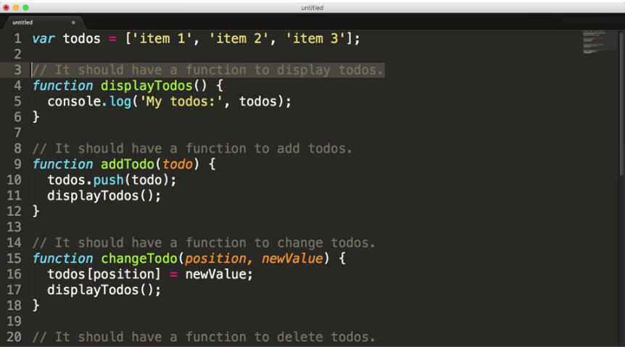

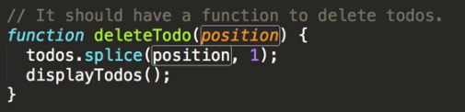

1. Objects

var ragav = {

name:'Ragav',

sayName: function(){

console.log(this.name);

}

}

undefined

ragav.sayName();

VM236:4 Ragav

Undefined

Requirements

It should store the todos array on a object

It should have a displayTodos method

It should have an addTodo method

It should have a changeTodo method

It should have a deleteTodo method

1. Booleans

Requirements:

todoList.addTodo should add objects

todoList.changeTodo should change the todoText property

todoList.toggleCompleted should change the completed property

1. Loops of logic

Syntax:

For(initialization;condition;final_expression){

Code to do function

}

for(var i=0; i < 3; i++)

{

console.log('Hey');

}

**Looping over arrays**

var testArray = ['item 1', 'item 2', 'item 3'];

undefined

testArray

(3) ["item 1", "item 2", "item 3"]

for (var i=0;i<3;i++){

console.log(testArray[i]);

}

VM278:2 item 1

VM278:2 item 2

VM278:2 item 3

undefined

for (var i=0 ; i< testArray.length; i++){

console.log(testArray[i]);

}

VM379:2 item 1

VM379:2 item 2

VM379:2 item 3

Requirements

displayTodos show .todoText

displayTodos should tell you if .todos is empty

displayTodos should show .completed

1. Thinking in code

Requirements:

* toggleAll: if everything’s true, make everything false.

todoList.addTodo('First');

script.js:12 My Todos:

script.js:19 () First

undefined

todoList.addTodo('Second');

script.js:12 My Todos:

script.js:19 () First

script.js:19 () Second

undefined

todoList.toggleCompleted(0);

script.js:12 My Todos:

script.js:16 (x) First

script.js:19 () Second

undefined

todoList.toggleCompleted(1);

script.js:12 My Todos:

script.js:16 (x) First

script.js:16 (x) Second

undefined

todoList.toggleAll();

script.js:12 My Todos:

script.js:19 () First

script.js:19 () Second

* toggleAll: if everything’s false, make everything true.

todoList.displayTodos();

script.js:9 Your todo list is empty

undefined

todoList.addTodo('first');

script.js:12 My Todos:

script.js:19 () first

undefined

todoList.addTodo('second');

script.js:12 My Todos:

script.js:19 () first

script.js:19 () second

undefined

todoList.toggleCompleted(0);

script.js:12 My Todos:

script.js:16 (x) first

script.js:19 () second

undefined

todoList.toggleCompleted(1);

script.js:12 My Todos:

script.js:16 (x) first

script.js:16 (x) second

undefined

todoList.toggleAll();

script.js:12 My Todos:

script.js:19 () first

script.js:19 () second

undefined

todoList.toggleAll();

script.js:12 My Todos:

script.js:16 (x) first

script.js:16 (x) second

Data types and comparisons

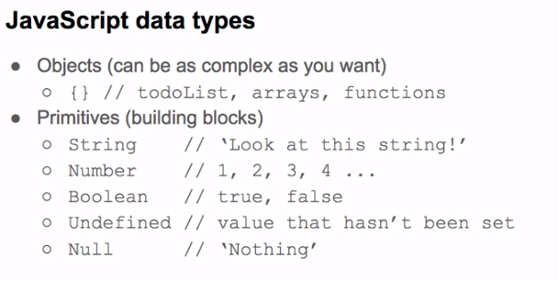

1. HTML and DOM

Requirements

* There should be a “Display todos” button and a “Toggle ALL” button in the app.
* Clicking “Display todos” should run todoList.displayTodos.
* Clicking “Toggle All” should run todoList.toggleAll.

1. Getting data from inputs

Requirements

* It should have working controls for .addTodo.
* It should have working controls for .changeTodo.
* It should have working controls for .deleteTodo.
* It should have working controls for toggle completed.

1. Escape from the console

Requirements

* There should be an li element for each todo
* Each li element should contain .todoText
* Each lli element should show .completed

1. Click to Delete

Requirements

* There should be a way to create delete buttons
* There should be a delete button for each todo
* Each li should have an id that has the todo position
* Delete button should have the access to the todo id
* Clicking delete button should update the todoList.todos and dom